***Environmental Care & Energy Saving***



**Engineering Co., Ltd.**

**#907 Daehyuntechnoworld, 174 Ojoen-dong, Ulwang-si, Kyunggi-do, Korea TEL: 82-31-458-7421 / FAX: 82-31-458-7425**

Subject : Experience Certificate

PROJECT : Central AC Project

LOCATION : Pakarab Fertilizers (Pvt.) Ltd. Multan TERM : <From> to <To>

NAME : <Name>

TRADE : <Designation>

It was confirmed that this guy has worked properly for completion of the CDM

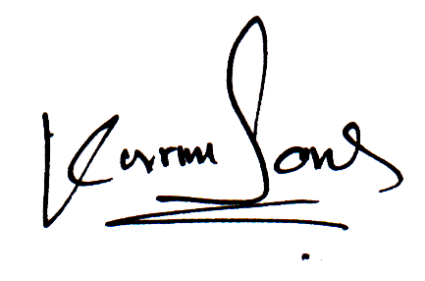

**For**



**K.S Engineering**